**AWS Business Intelligence Engineer Nanodegree – Project 2: Building an Application on Amazon Q Business**

**Automating the Career Coaching Process for Career4All**

**1. Executive Summary**

Career4All, a professional career development platform, faced operational inefficiencies in its manual career coaching process. The existing workflow required coaches to manually analyse learners’ CVs against job descriptions, identify skill gaps, and recommend relevant training programs. This process was time-consuming, inconsistent across coaches, and unable to scale with the growing learner base.

I designed and implemented a fully automated AI-powered career coaching application using Amazon Q Business to address these challenges. The solution leverages AWS’s no-code capabilities to streamline skill-gap analysis, automate training recommendations, and enforce secure access control, transforming Career4All’s manual system into a scalable, data-driven platform.

**2. Project Objectives**

The primary goals of this project were to:

* Automate skill-gap analysis by comparing student CVs and job descriptions using Amazon Q Business.
* Generate accurate, personalised training recommendations from Career4All’s course catalogue.
* Enable Career Coaches to refine recommendations through natural language prompts.
* Enhance scalability, efficiency, and consistency across the coaching process.
* Secure the application with user-based access controls and keyword moderation filters.

**3. Project Overview**

As part of the **Career4All Cloud Transformation Initiative**, this project focused on building a modular and intelligent coaching assistant capable of:

* Ingesting structured and unstructured documents (PDFs, job profiles, CVs).
* Analysing text data to detect skill mismatches.
* Providing real-time training recommendations and schedules from both static and dynamic sources.

The final solution was developed on **Amazon Q Business** and integrated with **Amazon S3**, **IAM Identity Centre**, and **Access Control Lists (ACLs)** for secure and reliable operation.

**4. Application Architecture**

The Career4All Coaching App was designed with the following functional architecture:

* **Frontend:** Amazon Q Business interface with multiple input and output cards.
* **Data Layer:** Amazon S3 bucket hosting Career4All’s training catalogue PDFs and synchronised data sources.
* **Logic Layer:** Skill analysis and recommendation logic built within Q App workflows.
* **Security Layer:** Access controls are configured through the IAM Identity Centre and ACL restrictions.
* **Moderation Layer:** Global keyword filtering for prohibited content (e.g., gambling, casino).

**5. Application Components**

**Input Cards**

To ensure flexibility and user convenience, I created multiple input methods:

* **Upload CV (File Input Card)** – allows users to upload PDF or Word resumes.
* **Paste CV (Text Input Card)** – enables direct text entry.
* **Upload Job Description (File Input Card)** – accepts job profile documents.
* **Paste Job Description (Text Input Card)** – for text-based entries.
* **Udacity Course Catalogue Upload Card** – imports the static PDF catalogue.

**Figure 1 – Amazon Q app Input Cards**

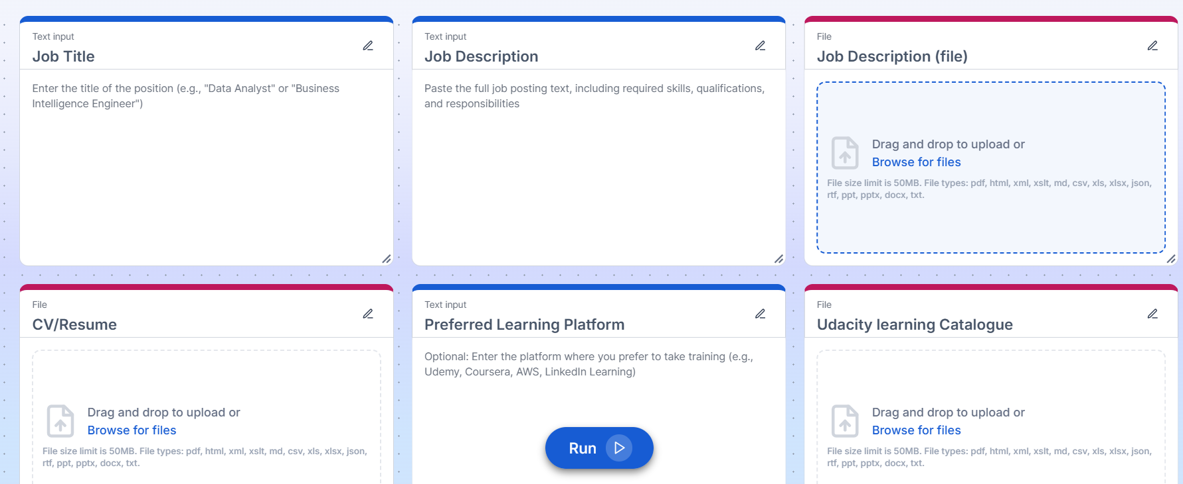

**Output Cards**

The output layer provides actionable and organised recommendations:

* **Skill Gap Analysis** – identifies missing competencies compared to job requirements.
* **Matching Skill Sets** – lists skills the learner already possesses.
* **Missing Skill Sets** – lists skills the learner needs to acquire.
* **Personalised Coach Recommendation** – generates coach-specific insights via natural language refinement.
* **Suggested Learning Schedule** – delivers a structured training timeline.

**Figure 2 (A) – Amazon Q App Output Cards  
  
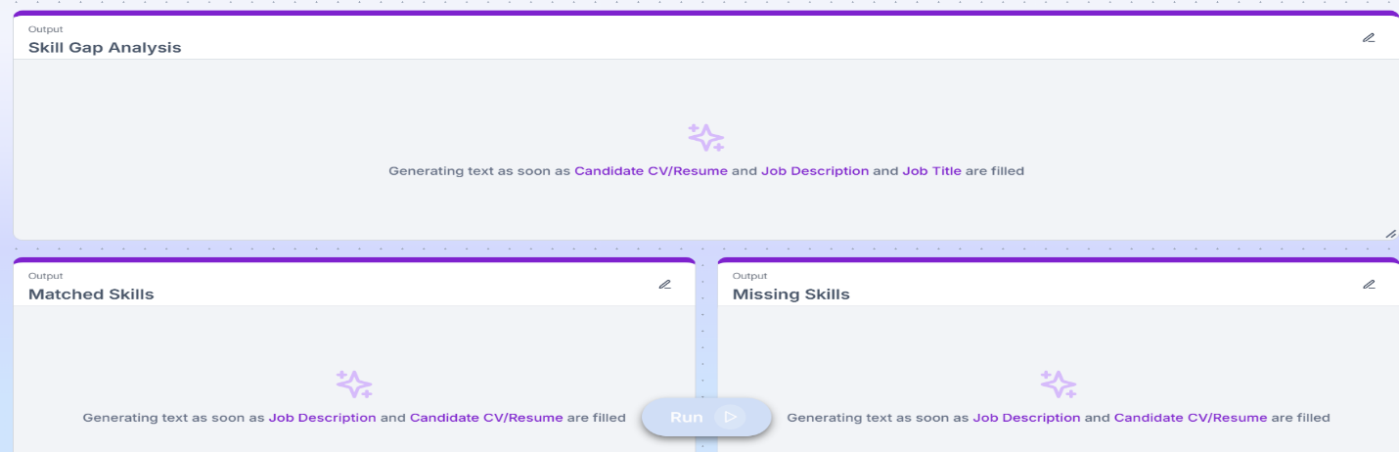  
Figure 2 (B) – Amazon Q App Output Cards  
  
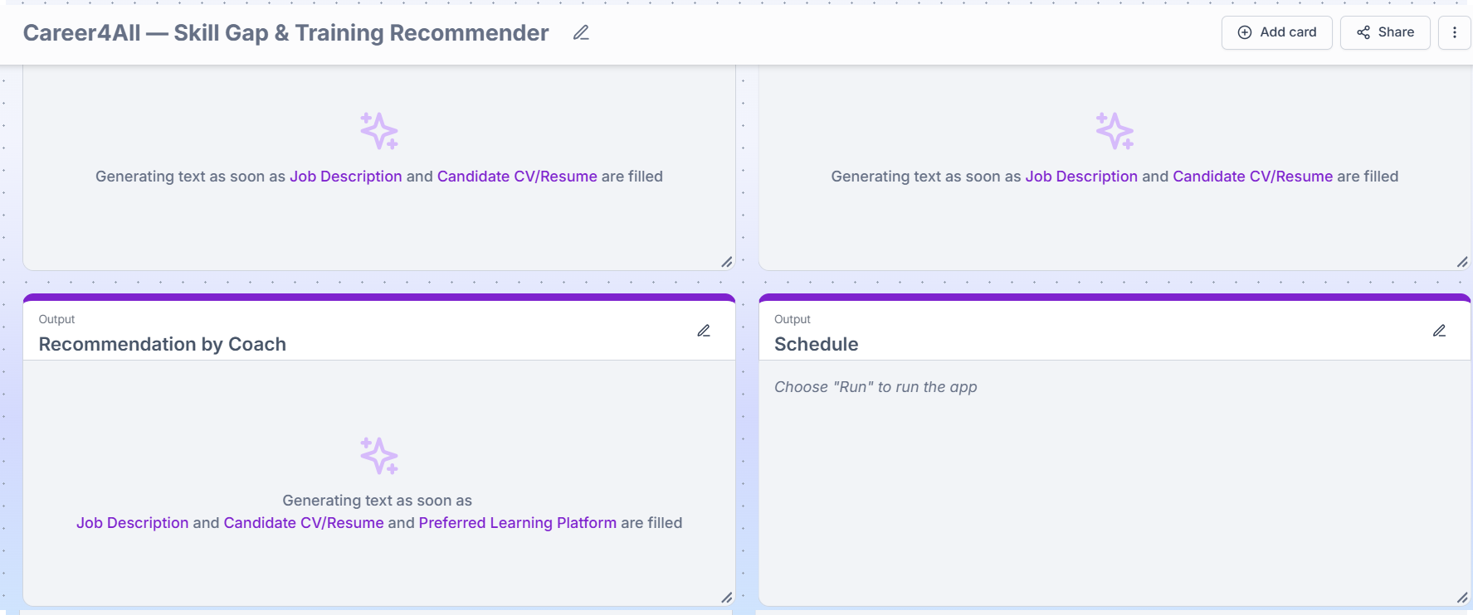  
  
Figure 2 (C) – Skill Gap Analysis Output Card Prompt  
  
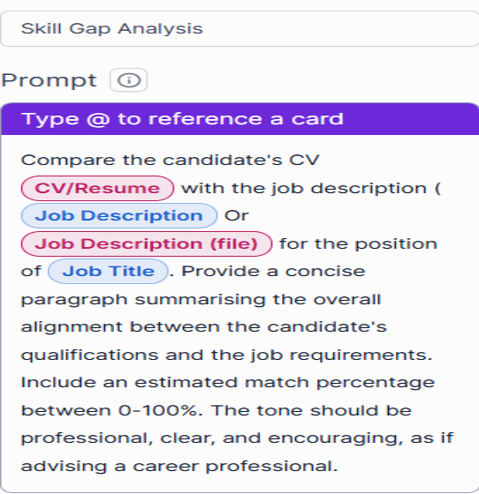**

**6. Data Integration and Synchronisation**

The app integrates both **static and dynamic data sources**:

* A **manually uploaded PDF catalogue** from Career4All’s internal repository.
* An **Amazon S3 bucket** (coaching-catalogues) configured for real-time training updates.
* A **daily scheduled sync** was set up to ensure training materials remain current.

This configuration guarantees that the coaching recommendations stay aligned with the latest available learning resources.  
  
 **Figure 3 (A) - Data Sources   
  
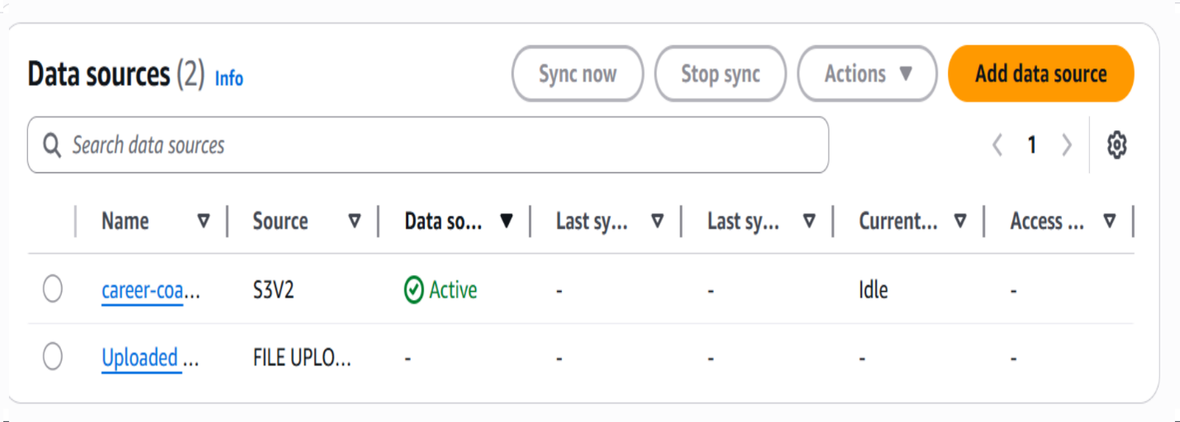  
  
  
Figure 3 (B) - Data Sources Uploaded Files Content**

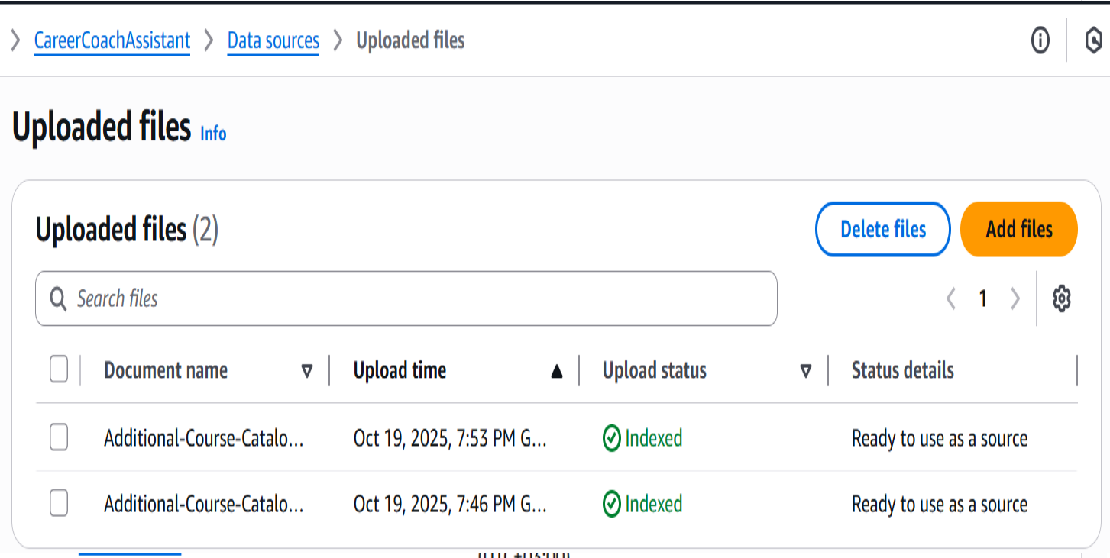

**Figure 3 (C) - Data Sources S3 Bucket Uploaded Content**

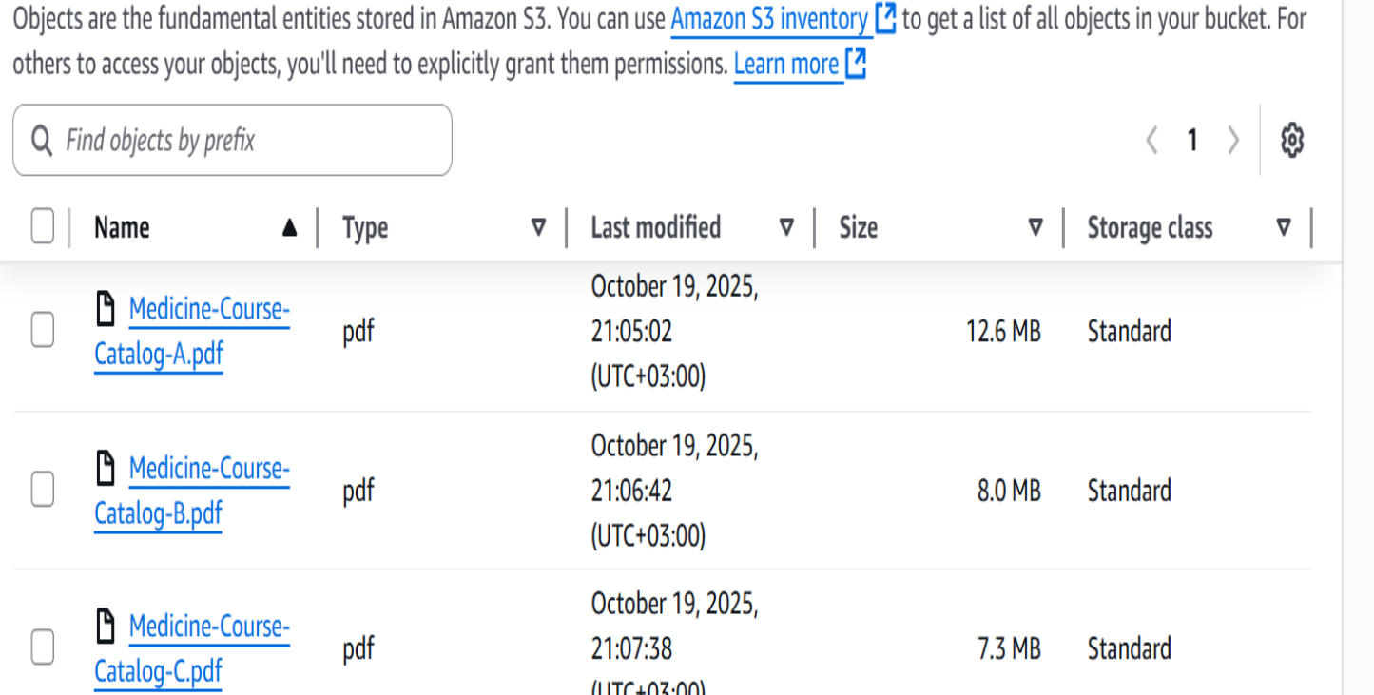

**Figure 3 (D) - Data Sources Upload and Active Indexing**

**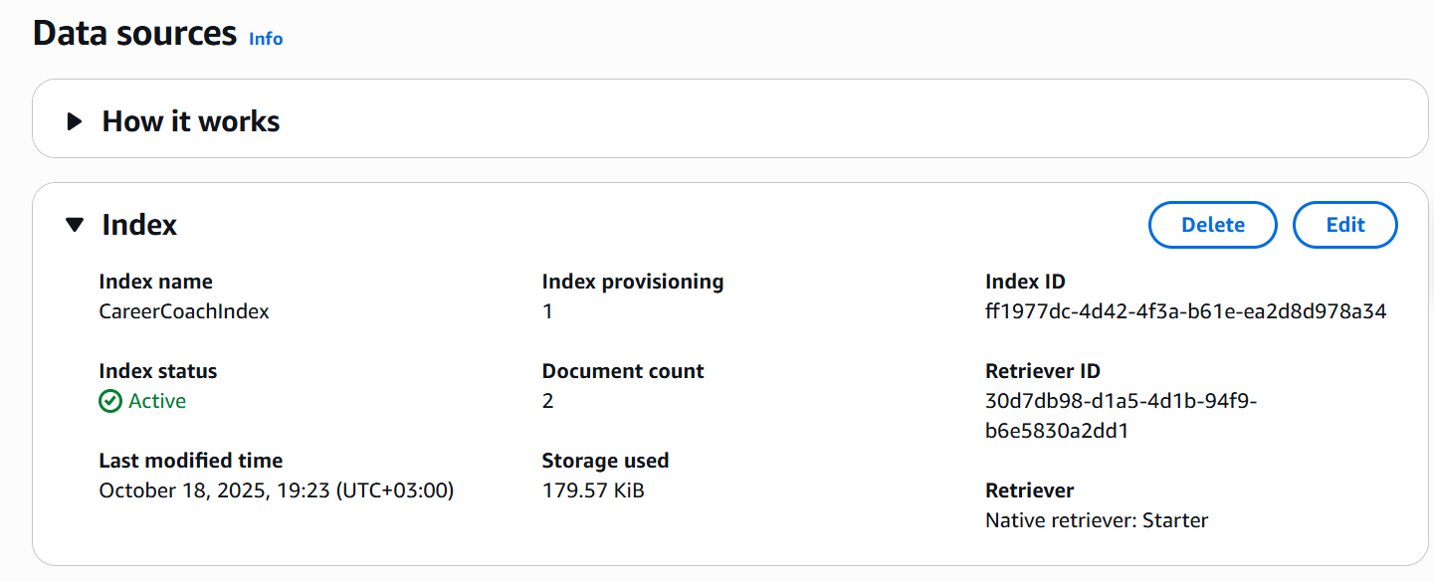  
  
Figure 3 (E) – Sync Run Schedule  
  
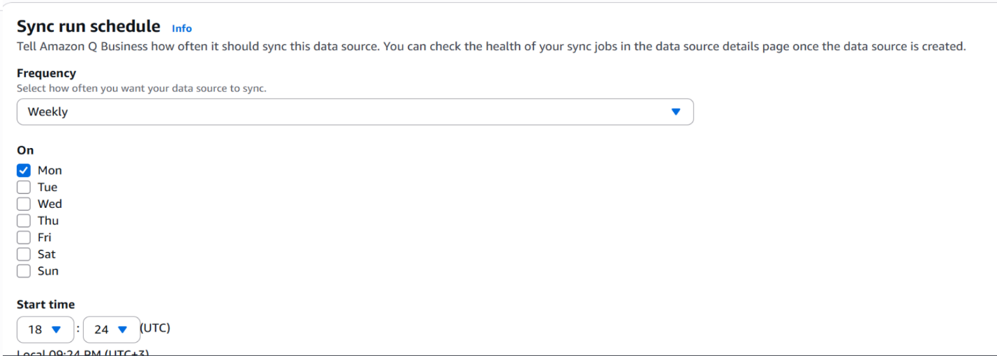**

**7. Security and Access Control**

Security was implemented at multiple levels:

* The **CareerCoaches** group and users (career.coach.one and career.coach.two) were configured via **IAM Identity Centre**.
* An **Access Control List (ACL)** was created and applied to the data source to restrict course visibility based on user roles.
* Access testing confirmed that restricted courses were visible only to authorised users.

**Figure 4 (A) – Access Control configuration**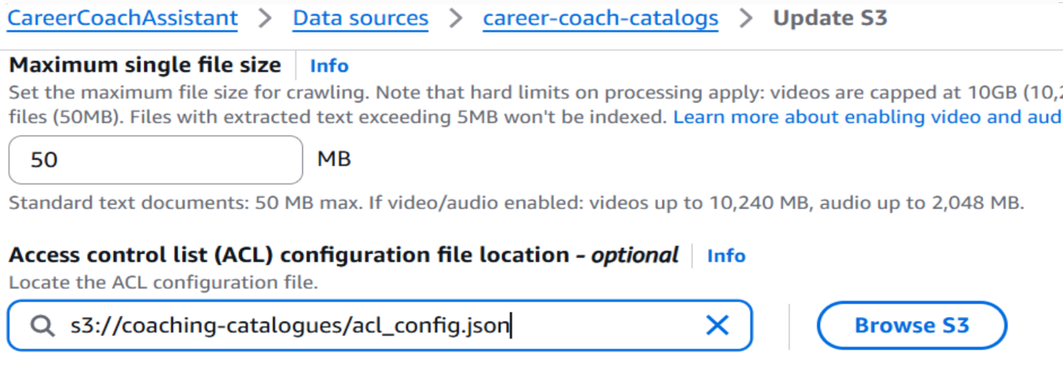

**Figure 4 (B) – Access Control configuration JSON file**

**Figure 4 (C) – Denied Access Example  
  
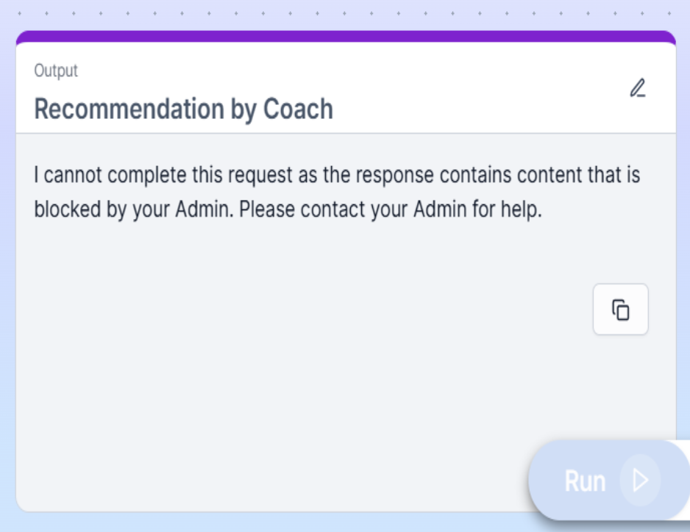**

**Figure 4 (D) – Granted Access Example  
  
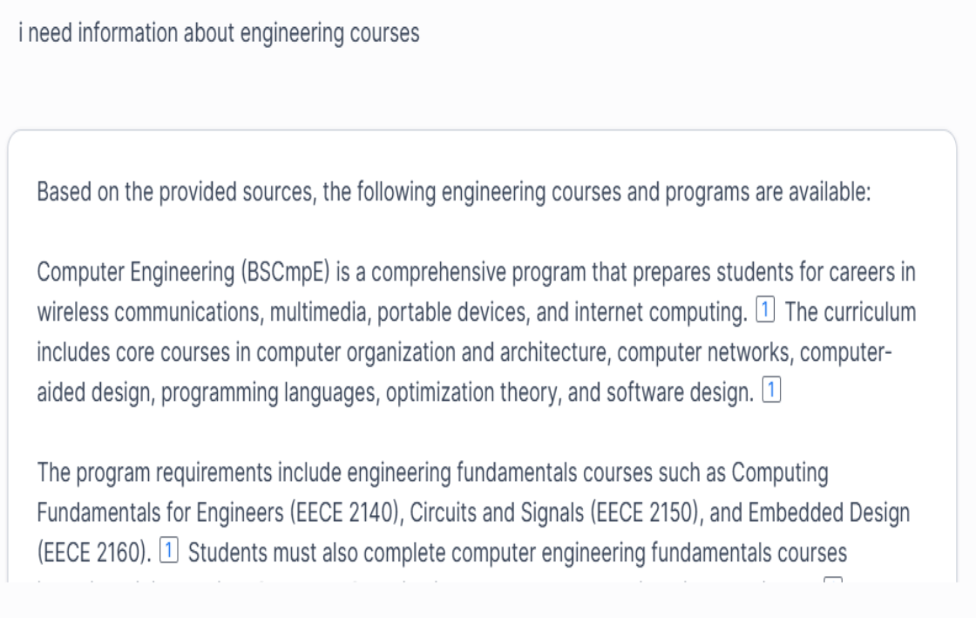  
  
8. Content Moderation**

A **Global Controls** policy was established in Amazon Q Business to block restricted keywords such as *“Gambling”,” Attack”,” Self-harm* and *“Casino”*. This ensured compliance with Career4All’s content integrity standards and maintained a safe, professional learning environment.  
  
**Figure 5 (A) – Blocked Words  
  
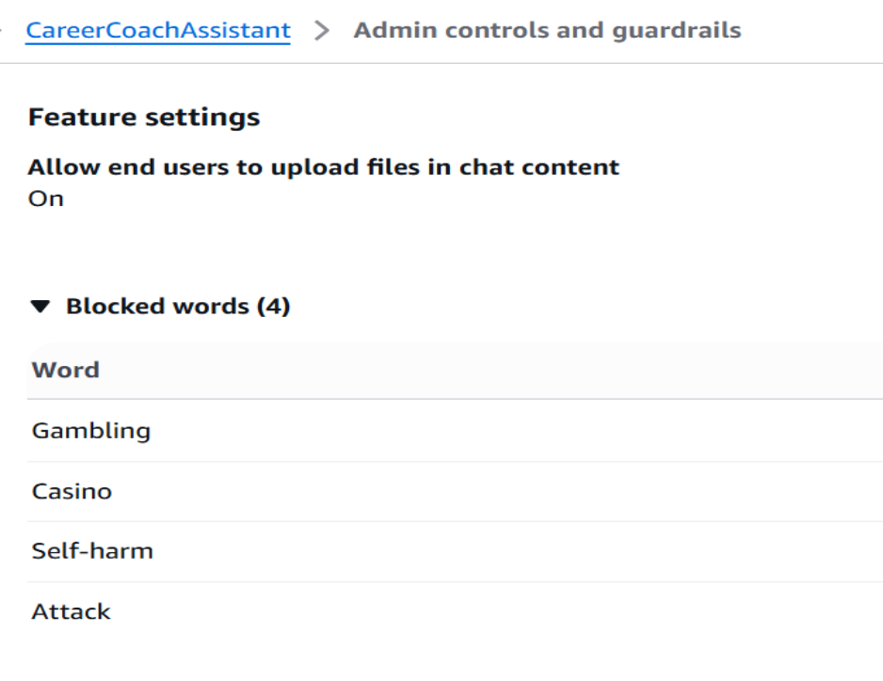**

**Figure 5 (B) - Topic Specific Controls  
  
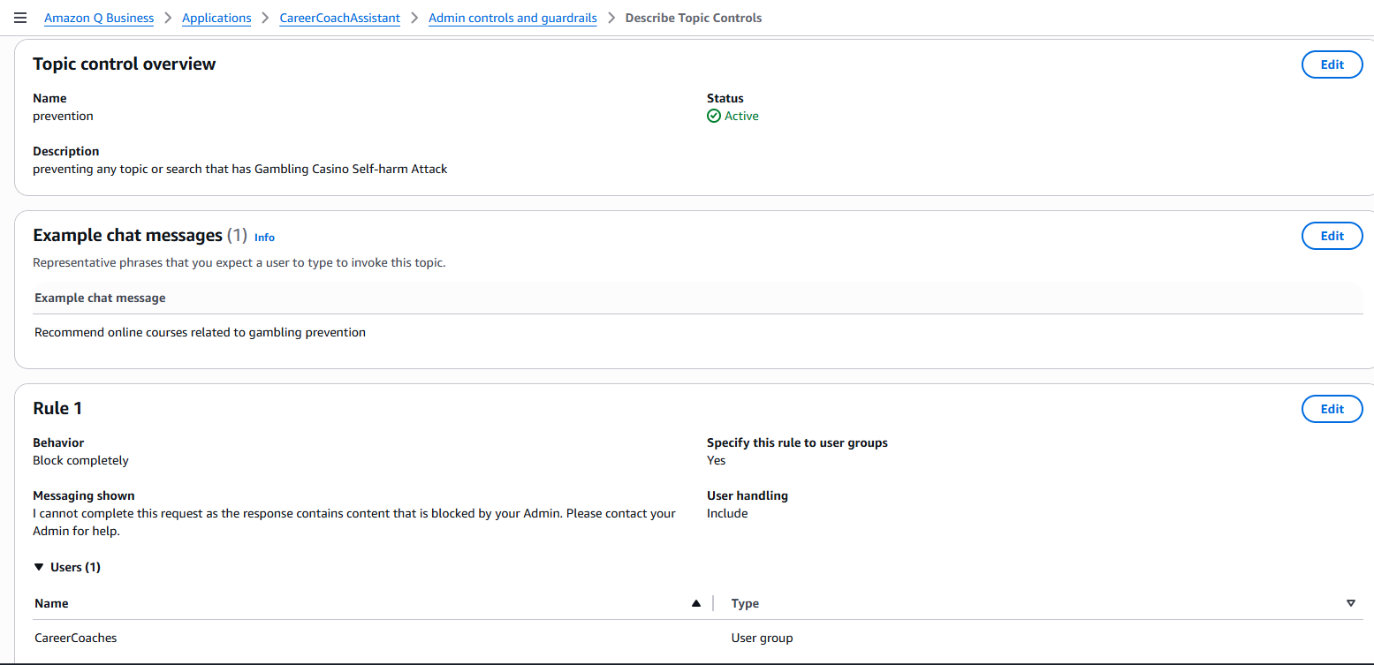**

**Figure 5 (C) – Blocked Word Practical Example  
  
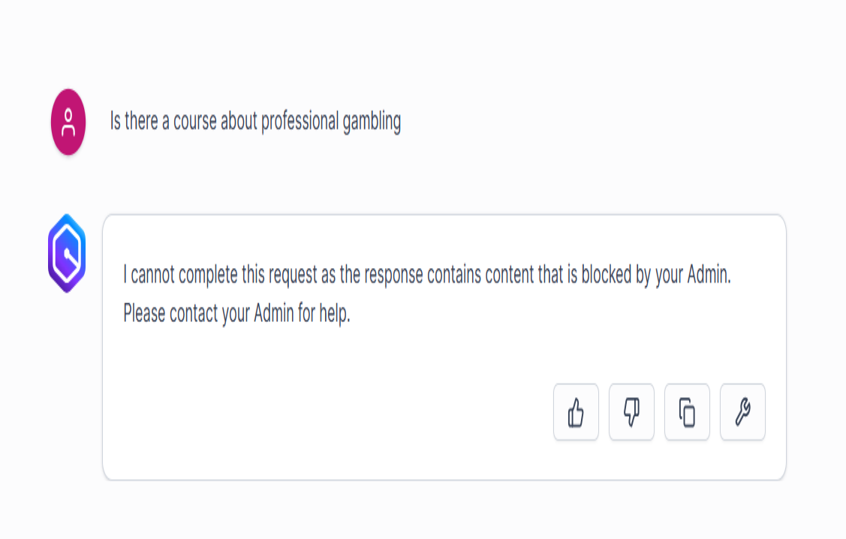**

**9. Application Verification and Publishing**

Once functionality and security were validated, the Career Coaching App was:

* Shared with the **CareerCoaches** group.
* Custom Categorisation including *“Career”,” Coaching”* and *“AI-powered”.*
* Published and verified within Amazon Q Business for production readiness.

**Figure 6 – Career4All App Sharing and Verification  
  
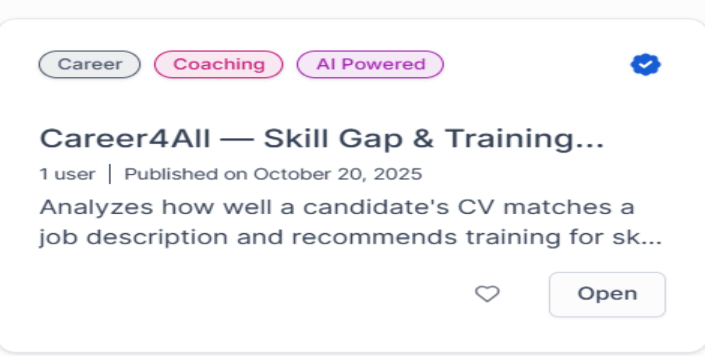**

**10. Demonstration and Output Samples**

To validate performance, I tested the app with a sample CV and job description.  
The output successfully demonstrated:

* Clear identification of skill gaps and matched skills.
* Tailored course recommendations based on detected deficiencies.
* A structured, personalised learning schedule generated through AI refinement.

**Figure 7 – Job Matching Generation Output Report**

***Candidate-Job Alignment Assessment (Skill Gap Analysis)***

*John Doe's profile shows moderate alignment with the Entry-Level Cloud Engineer position. Still, it appears to be mismatched with a Cloud Solutions Architect – Generative AI role, which typically requires advanced expertise. For the Entry-Level Cloud Engineer position, John demonstrates several key qualifications, including AWS Cloud Practitioner certification, problem-solving abilities, and relevant technical foundations through his Computer Science degree. His internship provided some cloud-based solutions experience, and his strong communication and collaboration skills align with the role's requirements. However, he lacks specific experience with 24x7 operational support, monitoring tools, ticketing systems, and certain technical skills like Linux/Windows administration and cloud security. For an Entry-Level Cloud Engineer position, I estimate a 60-65% match, suggesting he could be considered with additional training in the identified gap areas. For a Cloud Solutions Architect – Generative AI position (which appears to be different from the job description provided), the match would be significantly lower, as this typically requires advanced AI expertise and substantial cloud architecture experience not evident in John's current profile.****Training Recommendations for Missing Skills for Cloud Solutions Architect – Generative AI***

*| Missing Skill | Course Title | Platform | Description |*

*|---------------|-------------|----------|-------------|*

*| Generative AI & LLMs | Generative AI with Large Language Models | Coursera (DeepLearning.AI) | Learn the fundamentals of how LLMs work and how to implement them in real-world applications. |*

*| AI/ML Frameworks | Deep Learning with PyTorch: Zero to Mastery | Udemy | Comprehensive course on PyTorch, TensorFlow, and Hugging Face libraries for building AI models. |*

*| Cloud AI/ML Services | AWS Machine Learning Speciality Certification | AWS Training | Deep dive into AWS AI services, including SageMaker, Bedrock, and other ML solutions. |*

*| Python for AI/ML | Python for Machine Learning & Data Science | Udemy | Focused training on Python programming specifically for AI/ML applications. |*

*| Model Fine-tuning | Fine-tuning Large Language Models | LinkedIn Learning | Learn techniques for adapting pre-trained LLMs to specific use cases and domains. |*

*| Prompt Engineering | Prompt Engineering for Developers | Coursera (DeepLearning.AI) | Master the techniques for effectively communicating with and optimising AI models. |*

*| Kubernetes & Containerization | Kubernetes for Machine Learning Deployment | edX | Learn to deploy and manage AI models in containerised environments using Kubernetes. |*

*| MLOps & CI/CD | MLOps: DevOps for Machine Learning | Coursera | Comprehensive training on building CI/CD pipelines specifically for ML model deployment. |*

*| Vector Databases & RAG | Building RAG Applications with Vector Databases | Udemy | Learn to implement retrieval-augmented generation with vector databases like Pinecone and Weaviate. |*

*| AI Ethics | Responsible AI: Ethics in Technology | edX | Understand AI ethics principles and how to implement responsible AI solutions. |*

*| NLP Fundamentals | Natural Language Processing Specialisation | Coursera | Foundation course in NLP concepts, techniques and applications. |*

*| Technical Content Creation | Creating Technical Learning Content | LinkedIn Learning | Learn how to develop workshops, documentation and educational materials for technical audiences. |* ***Training Schedule*** ***# 4-Week Personalised Learning Schedule for John Doe***

***## Week 1: Foundation Building***

*\*\*Monday - Wednesday\*\**

*- **Course**: "AWS Monitoring and Observability" (Udemy)*

*- **Duration**: 8 hours total (2-3 hours per day)*

*- **Focus**: Leveraging your AWS certification by building monitoring skills essential for the role*

*\*\*Thursday - Friday\*\**

*- **Course**: "Linux Administration Bootcamp" (Udemy)*

*- **Duration**: 6 hours total (3 hours per day)*

*- **Focus**: Core system administration skills required for cloud infrastructure management*

*\*\*Weekend\*\**

*- **Course**: "IT Service Management Fundamentals" (Coursera)*

*- **Duration**: 4 hours total (self-paced)*

*- **Focus**: Introduction to ticketing systems and service management*

***## Week 2: Technical Skill Enhancement***

*\*\*Monday - Tuesday\*\**

*- **Course**: "Python for DevOps" (Coursera)*

*- **Duration**: 6 hours total (3 hours per day)*

*- **Focus**: Building scripting skills to automate cloud operations*

*\*\*Wednesday - Thursday\*\**

*- **Course**: "AWS Security Essentials" (AWS Training)*

*- **Duration**: 6 hours total (3 hours per day)*

*- **Focus**: Securing cloud environments, a critical requirement for the role*

*\*\*Friday - Weekend\*\**

*- **Course**: "Microsoft Azure Fundamentals" (Microsoft Learn)*

*- **Duration**: 8 hours total (spread across 3 days)*

*- **Focus**: Expanding cloud knowledge beyond AWS to include Azure*

***## Week 3: Operational Processes***

*\*\*Monday - Tuesday\*\**

*- **Course**: "IT Incident Management" (edX)*

*- **Duration**: 6 hours total (3 hours per day)*

*- **Focus**: Learning incident response protocols essential for support roles*

*\*\*Wednesday - Thursday\*\**

*- **Course**: "Problem Management and Root Cause Analysis" (edX)*

*- **Duration**: 6 hours total (3 hours per day)*

*- **Focus**: Developing analytical troubleshooting techniques*

*\*\*Friday - Weekend\*\**

*- **Course**: "Introduction to Infrastructure as Code" (LinkedIn Learning)*

*- **Duration**: 6 hours total (spread across 3 days)*

*- **Focus**: Understanding automation tools for cloud environments*

***## Week 4: Advanced Skills & Work-Life Preparation***

*\*\*Monday - Tuesday\*\**

*- **Course**: "Cloud Infrastructure Maintenance Best Practices" (A Cloud Guru)*

*- **Duration**: 6 hours total (3 hours per day)*

*- **Focus**: Learning maintenance procedures for cloud systems*

*\*\*Wednesday - Thursday\*\**

*- **Course**: "ITIL 4 Foundation" (Pluralsight)*

*- **Duration**: 8 hours total (4 hours per day)*

*- **Focus**: Understanding IT service management framework*

*\*\*Friday\*\**

*- **Course**: "Managing Shift Work and Work-Life Balance" (LinkedIn Learning)*

*- **Duration**: 3 hours*

*- **Focus**: Preparing for the 24x7 shift environment requirement*

***## Summary***

*This learning schedule strategically addresses John's skill gaps for the Entry-Level Cloud Engineer position by prioritising the most critical technical skills first (monitoring, Linux administration, security) before moving to operational processes and specialised knowledge. The plan leverages John's existing AWS certification and problem-solving abilities while building complementary skills in operational support, multi-cloud environments, and system administration. The schedule is designed to be realistic for someone with full-time commitments, with approximately 10-15 hours of learning per week. By following this plan, John can systematically improve his qualification match from approximately 65% to potentially 85%+ within just one month, significantly enhancing his candidacy for the position.*

**11. Key Achievements**

* Reduced the time spent on skill-gap analysis and training mapping by **over 90%**.
* Enabled **automated updates** through Amazon S3, ensuring continuously fresh training data.
* Established a **secure, role-based access system** protecting proprietary course content.
* Enhanced consistency and scalability across the coaching team.
* Delivered a fully functional, production-ready **AI career coaching assistant**.

**12. Lessons Learned**

Building this solution provided valuable hands-on experience in:

* Leveraging **Amazon Q Business** for no-code intelligent automation.
* Designing secure, scalable architectures within AWS ecosystems.
* Integrating structured and unstructured data for analytical use cases.
* Balancing automation with human refinement to preserve quality insights.

**13. Conclusion**

Through this project, I successfully transformed Career4All’s manual coaching workflow into a data-driven, automated, and scalable solution using **Amazon Q Business**.  
The application demonstrates how AI and cloud integration can redefine traditional business processes, reducing overhead, improving accuracy, and empowering professionals with real-time, intelligent tools.

This project not only meets the AWS/Udacity Nanodegree criteria but also stands as a **portfolio-grade enterprise case study**, reflecting real-world AWS solution engineering, business intelligence design, and applied automation.

**Attachments**

1. Word/PDF – Training Recommendations and Learning Schedule Output
2. Screenshots – Application Interface, Data Sources, ACLs, and Blocked Keywords
3. ACL File – Access Control Configuration